

**CMPE 208 - REPORT**

**Session Initiation Protocol**

**(SIP)**

**Team Associates – Group 12**

Monica Ashok Kumar (011436815)

Nidhi Agarwal (010728094)

Sachin SP (011425856)

Suhas Janardhan (011169054)

**Contribution of each Team Member:**

|  |  |
| --- | --- |
| **Member** | **Contribution** |
| Nidhi Agarwal | Detailed Analysis of SIP Architecture |
| Monica Ashok Kumar | Lab Setup, Execution and Wireshark analysis |
| Suhas Janardhan | Detailed Analysis of SIP Messages and Attacks |
| Sachin S P | Lab Setup, Execution and Wireshark analysis |

**Introduction**

Voice over IP is an emerging technology which uses the Internet Protocol to transmit audio data over a data network. The main advantage of VOIP is increased efficiency and decrease cost. These days applications like Skype, Viber, WhatsApp, etc. VoIP uses protocol like RTP for voice transmission and signaling protocol like SIP to process a call.

Most of the VOIP applications use RTP (Real-time transport protocol) to send voice data between source and destination using port address and IP address over internet and SIP, as its signaling protocol in performing the basic operations which are creation, termination and management of sessions between hosts in any IP based network. SIP provides a mechanism to

* Creating a multimedia session over the Internet
* Maintaining a session between users
* Modifying a session (Change of parameters in mid-session)
* Session Termination

**Overview**

Session Initiation Protocol (SIP) is a signaling protocol and was designed by Internet Engineering Task Force (IETF) and RFC 3261 documents SIP. It is an application layer protocol which is used to create, maintain and terminate media sessions. These sessions may include audio, instant messaging and video. SIP is designed to be independent of the underlying transport layer and it runs on TCP, UDP. It is a text based Protocol similar to the Hypertext Transfer Protocol. Users can be added to already existing sessions using SIP. It developed by the SIP working group within the Internet engineering Task Force (IETF) multimedia data and control architecture.

**SIP Architecture:**

SIP is used for peer-to-peer communication, though it uses a client-server model. The SIP participants is as shown below:

* User Agents
* SIP Proxy
* Location Server
* SIP Registrar
* SIP Redirect server

**User Agents**:

User agents (UAs) are end users An user agent client (UAC) creates and sends requests and an user agent server (UAS) responds and processes to each request generated by a UAC.

**Servers**: These handle client requests and can be:

**Proxy server:**

A proxy server receives a request and forwards it towards the server that might know the location of caller or forward directly to the caller. Proxy servers execute call signaling on the behalf of the parties they serve. It also performs an authentication function. Proxy Server lies in the path of call routing. Server, do it based on the routing rules and data base.

**Redirect server:**

A redirect server receives a request and informs about next hop server to caller’s UA. The caller’s UA then contacts the next hop server directly. Redirect Server determines the location of called party and give out the address to calling party. Then calling party can directly contact the party. Redirect server is not staying in the path of call. Server mainly used for location purpose.

**Registrar server**:

UA’s contact this server mainly to register for the service.

**Location Server:**

This server acts as a database which contains all the locations as well as user preferences as indicated by the User agent (UA). It has all the information like port address and IP address of all connected users. It also updates its data base according to the changes in connection between server and client. It also performs authentication function.

Fig below show basic components involved in SIP.

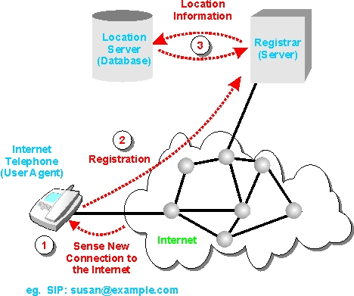

**Fig:** Basic components of SIP

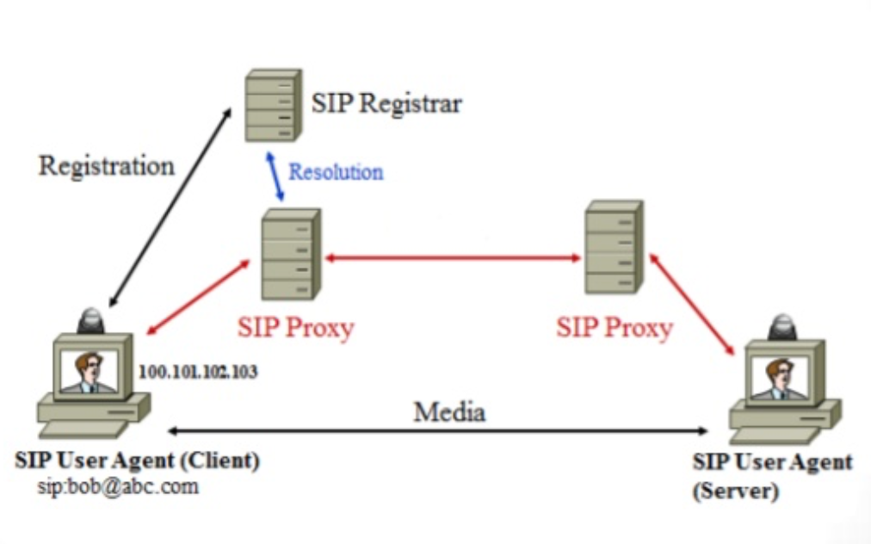

**Fig:** Basic components of SIP

**SIP Messages:**

SIP is a text-based protocol with syntax similar to that of HTTP. There are two different types of SIP messages:

* Requests
* Responses.

SIP requests are used to establish communication. SIP responses indicate whether request succeeded or failed. SIP requests are generally called METHODS.

METHODS are distinguished into 2 types:

* Core Methods
* Extension Methods

**Core Methods:**

There are 6 core methods discussed below.

**INVITE:**

This is used to establish a media session between user agents. It may contain media content of caller in its message body. A successful session is considered to be established if INVITE receives a response(2xx) or ACK has been sent. INVITE request creates a dialog between two user agents which continue until BYE is used to end the session. INVITE within an already established dialog is called re-INVITE. It is used to change the characteristics of session or refresh dialog state.

Below is the flow messages and an example of INVITE

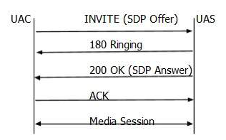

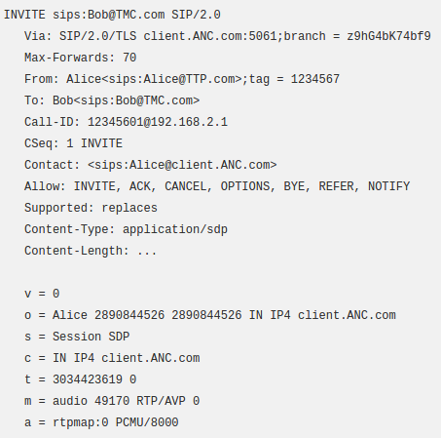

**Fig**: Flow of INVITE Method

**BYE:**

BYE method is used to end the established session. This is a SIP request that can be sent by either caller or callee to terminate the session. Proxy server can’t send this request. This request normally routes end to end, bypassing proxy server. BYE can’t be send to an unestablished session or pending INVITE.

**REGISTER:**

This request is sent by user to registrar server. User agent gets registered with this request. It may be proxied or forwarded until it reaches specific domain or authoritative registrar. TO header contains AOR(Address of Record) of the user being registered. It contains the time period(3600 sec). REGISTER request can be sent from one user agent on behalf of other and this is known as third-party registration. From tag contains the URI of user agent submitting the registration on behalf of the user agent identified in the TO header.

**Cancel:**

It is used to terminate unestablished sessions. This request is used by user agents to cancel a pending call attempt initiated earlier. It can be sent by either proxy server or user agent. It is a hop by hop request i.e, it traverses through elements between user agent and receives response generated by next element. Below is the flow of CANCEL

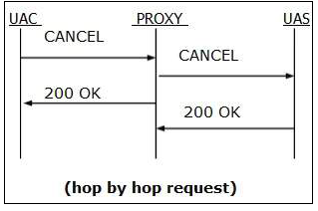

**Fig**: Flow of CANCEL Method

### ACK

It is used to acknowledge the INVITE method. Its direction is same as that of INVITE. ACK may contain SDP body also. ACK can not modify media description that has already been sent in INVITE. Stateful proxy receiving an ACK must determine whether or not ACK forwarded to proxy or user agent. ACK is end to end for 2xx responses. It works on hop by hop when stateful proxies are involved.

### 

**Fig**: Flow of ACK Method

### OPTION:

Used to query user agent or proxy server for its capability and current availability. Proxy does not generates OPTION request.

**EXTENSION METHODS**

**SUBSCRIBE:**

Used by user agents to create a subscription for the getting notification for particular event. After the time period subscription will terminate automatically. It contains Expires header which indicates duartion of subscription. It creates a dialog between user agents. Another SUBSCRIBE can be sent within dialog before expiration time. 200 OK will be received by user for subscription. User can unsubscribe by sending SUBSCRIBE with expires value as 0.

**NOTIFY:**

### Used by user agents to get know the occurrence of particular event. It is triggered within dialog when there is subscription between subscriber and notifier. 200OK is received as response. It has event handler which indicates an event. It can also be sent at start and termination of subscription. Below is the example of SUBSCRIBE and NOTIFY

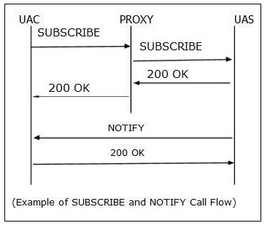

**Fig**: Flow of SUBSCRIBE and NOTIFY Method

**PUBLISH:**

Used to send event information to server by user agent. It is useful when there are many sources of event information. It is not sent in dialog. Below is the sample for PUBLISH

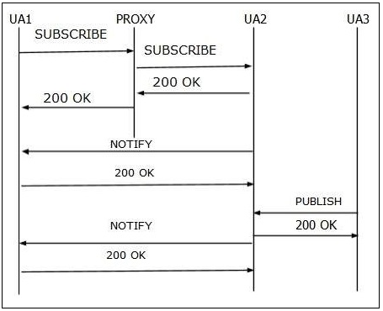

**Fig**: Flow of PUBLISH Method

**REFER:**

Used to refer user agent by another user agent to access URI for dialog. It should contain Refer-To header. It can be either inside or outside a dialog. Once the other user agent has accepted the reference 202 Accepted will trigger.

**INFO:**

Used to send signaling information to user agent by another user agent with which it has media session established. It is always forwarded by proxy and it is an end-to-end request.

**UPDATE:**

It is used to update the session if session has not been established. User can change CODEC with update. Below is the sample for UPDATE

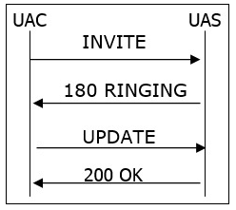

**Fig**: Flow of UPDATE Method

**PRACK:**

It is used as an acknowledgment for the received reliable transfer of provisional response(1xx). It is generated by client when it receives provisional response. Rack header contains (RSeq+CSeq). It is not applied to 100 trying response, which is never reliably transported. It may contain a message body.

**MESSAGE:**

SIP uses this in order to send instant message. It usually consists of messages of participants exchanged in real time during text conversation. It can be within or outside the dialog box. Message contents are carried as MIME attachment. 200 OK response is received to indicate that message has been sent to destination. Below is the sample for MESSAGE

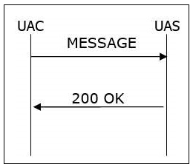

**Fig**: Flow of MESSAGE Method

### SIP Responses:

Responses are sent by the user agent server acknowledging the received request. Many of SIP responses are borrowed from HTTP. Several classes of responses are recognized, determined by the numerical range of result codes:

|  |  |  |
| --- | --- | --- |
| 1XX | Provisional message | Request received and continue to process it |
| 2XX | Successful | Successfully received, processed and accepted. |
| 3XX | Redirection | Some action needs to be taken to complete the request. |
| 4XX | Client Error | Bad request or can not be processed by server. |
| 5XX | Server Error | Server failed to process the valid request. |
| 6XX | Global Failure | Request can not be processed at any server. |

Once the session is initiated packets are transferred using RTP and RTCP.

**RTP (Real-time transport protocol):**

Provides delivery services for interactive video and audio data with real-time characteristics. RFC versions are RFC 3550 and RFC 3551. RTP has two parts:

* **Real time protocol**: this carries real-time data.
* **Real time control protocol**: it is mainly used to monitor the QOS and gives the information about the users participating.

If both video and audio media are used in conference then separate RTP sessions are used and transmitted via RTCP packets. Each medium uses two different UDP ports and addresses.

Users can take part simultaneously in conference with the help of mixers in RTP.

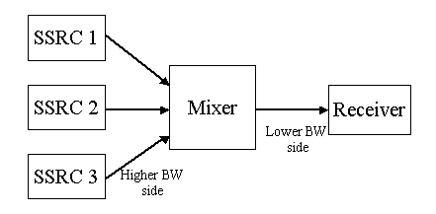

**Fig:** Mixer in RTP

Mixer synchronizes incoming audio packets and mixes these reconstructed streams into a single stream. It puts identification as the source(SSRC) and puts contributing source in CSRC fields. It also does the same for video streams

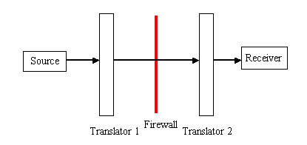

**Fig:** Translation in RTP

These helps if there is a firewall in between the users which won’t allow the IP packets to be transferred between them. Separate translators are placed as shown above in the snapshot.

RTP packets are transmitted using UDP.

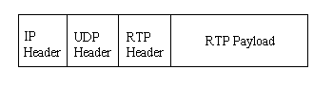

**Fig**: RTP packet structure:

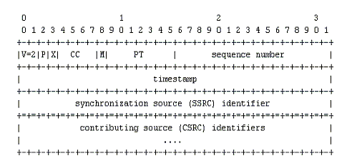

**Fig:** RTP header format

**RTCP(Real Time Transmission Control Protocol):**

Involves in periodic transmission of control packets to all the users in the session.

Functions of RTCP:

* Quality of the data distribution feedback is provided.
* Each participant sends there control packets to others in session, which enables users to get to know the number of participants. We will also be able to know the rate at which packets are sent.
* It carries a persistent identifier for an RTP source called CNAME( canonical name) which helps to identify participant during the session.

RTCP packets:

* SR: Sender report
* RR: receiver report
* SDES: Source description items
* BYE: this informs the end of application
* APP: Functions specific to applications

**Basic SIP Call Scenario:**

SIP is used to setup a session to send audio, video messages by using RTP, RTCP between users and to terminate the session when it’s over. Voice information must be encoded before sending it over the internet. Two of the most used codecs are: **G.711** and **G.729.** Encoded packets are transported using real-time transport protocol(RTP).

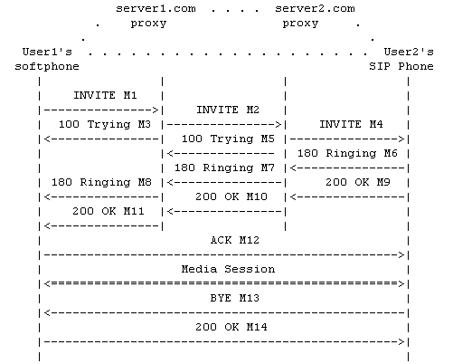

**Fig:** SIP Call Flow

User1 is using a soft phone and trying to connect User2’s SIP phone. Following steps happen:

* User1 sends an INVITE request for user2 but it doesn’t know the location of user2 so the request is sent to server1(proxy server).
* Server1 on behalf of user1 forwards the INVITE request to server2 and sends a TRYING response to user1 telling that it is trying to reach user2.
* Server2 also works in similar fashion it forwards the INVITE request to user2(since it knows the location of user2 otherwise it would have forwarded the request to another proxy server) mean while it send TRYING response to server1.
* User2 on receiving the request has a choice to accept and decline the call. Let’s assume user2 accepts the request. 200 OK response is sent to server2 which in turn sends to server1 and finally to user1.
* User1 on receiving 200 OK response sends an ACK message to confirm te setup of the call.
* Once the session is created media is transmitted between users.
* Suppose user2 wants to leave the session then it sends BYE message to other party and in return it gets 200 OK response.

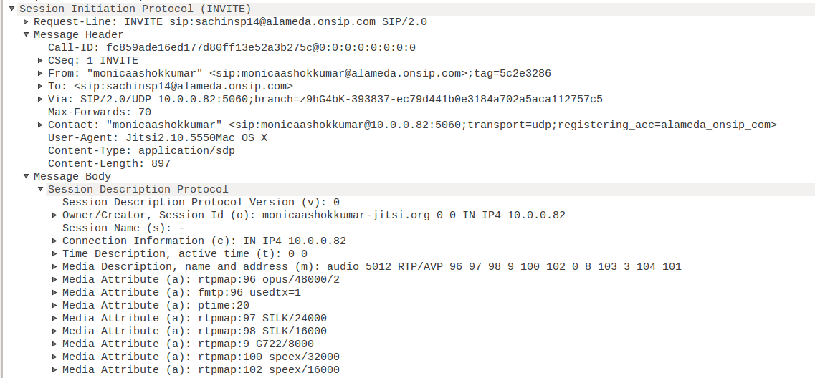

**Fig:** Request message format of SIP

First line is Request-Line indicating that it is request.

Here method is INVITE request URI is “sachinsp14@alameda.onsip.com” and sip version is 2.

Following are set of header fields:

* VIA: contains the address of user sending a request i.e “monicaashokkumar@alameda.onsip.com”.
* MAX-FORWARD: used to limit the count of hops before reaching the recipient. It avoids the looping problem.
* TO: it contains the other user to which request is sent.(sachinsp14@alameda.onsip.com)
* FROM: user sending the request(monicaashokkumar@alameda.onsip.com)
* CALL-ID: generated as a combination of pseudo-random string and softphone’s IP address. It is unique for each call.
* CSEQ: consists of an integer and a method. It is used to detect non-delivery of a message.
* CONTACT: It contains the SIP URI of sender.
* CONTENT-TYPE: consists of description of message body.
* CONTENT-LENGTH: octet count of the message body.

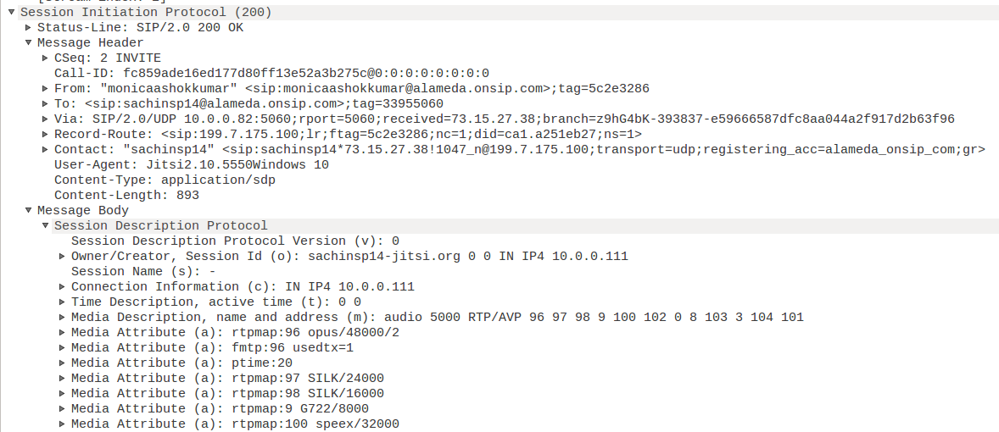

**Fig:** Response message contents

* First line tells that method is response that is status line.
* VIA: response follows the same path as INVITE using VIA fields.
* TO: this field contains tag now which is used to represent the callee.
* CONTACT: this now contains the address of recipient so that sender doesn’t need to use the proxy servers to find recipient in future.

**SIP Terminologies:**

**MESSAGES**: two types of messages - REQUEST and RESPONSE. They are usually text bodies exchanged between client and servers.

**TRANSACTION**: it contains all the messages between client and server starting from the request sent by client till the last response sent by server

**DIALOG**: dialog is identified by call-id. It is a SIP relationship between two user agents which stays for some time.

**CALL**: it comprises all the dialogs. It is same as session.

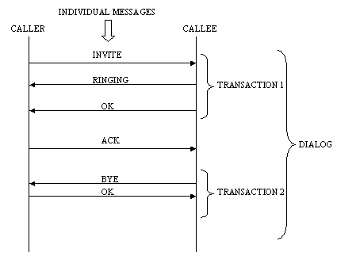

**Fig:** SIP Terminologies

**SIP Registration:**

Usually caller will not be familiar with the callee address initially. Proxy servers helps in finding the address of the recipient. At the start every user register themselves with REGISTRAR server. Application sends REGISTRAR message informing the server its location. Registrar stores this binding in location server which then will be used by proxies to locate the user.

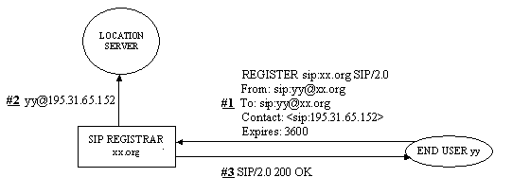

1. User yy sends register request to registrar.
2. Registrar stores the binding in location server.
3. Registrar sends 200 OK response.

**Lab setup:**

We have made use of Jitsi application for analyzing SIP.

**JITSI application setup:**

Jitsi is an open source videoconferencing and instant messaging application for Linux, Windows, Android and Mac OS X. It supports telephony protocols, video/voice streaming and conferencing like SIP, RTP/RTCP etc. Below snapshots show the setup of Jitsi application:

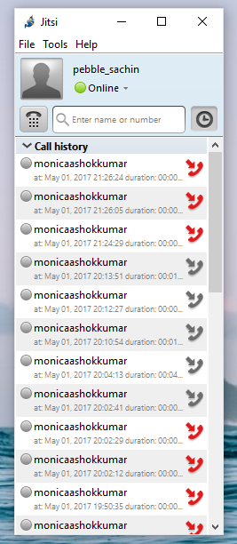

**Fig:** Jitsi interface on our desktop

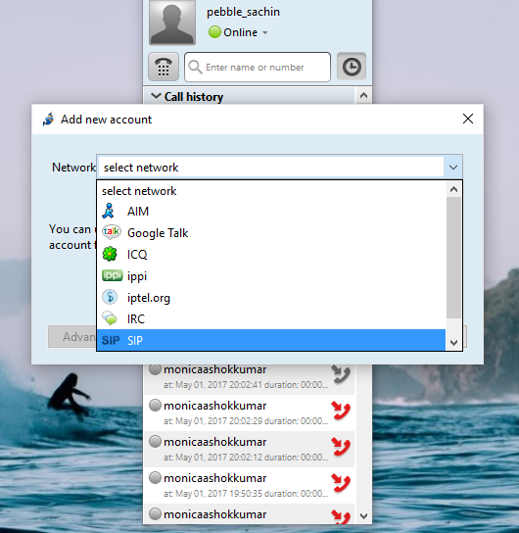

Jitsi gives us options to setup multiple accounts. We have created a SIP account for our lab setup.

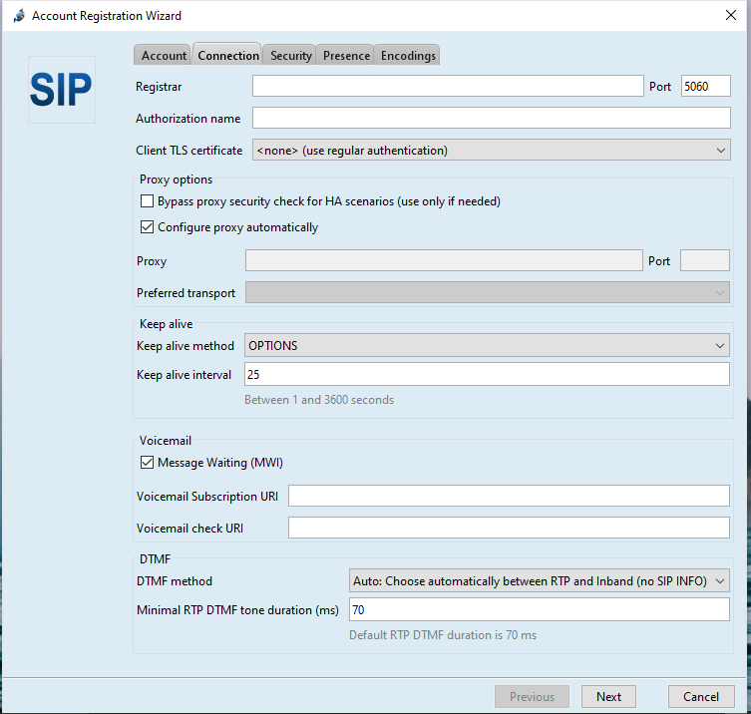

Following details are filled to setup the Jitsi. Along with the connection, security, encodings and other settings are made and once everything is done status will be shown online and is good to go.

Next important thing we need in this project is domain.

**Domain setup:**

In order to use the Jitsi application or any other voip applications we need to have a dedicated domain. We have made use of “Onsip.com” which provides a free domains.

Below screen shot shows the admin page and we have the domain name- “alameda.onsip.com”. Admin can view his current users along with their extension, status also.

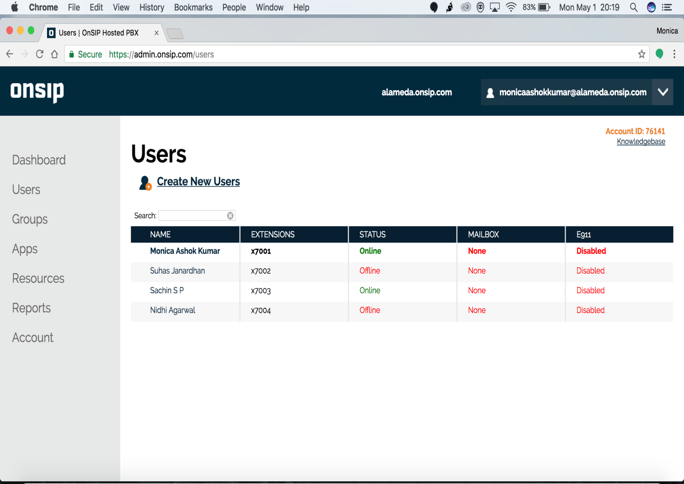

**Fig:** Domain Setup

Below snapshot shows the details of users such as SIP address, Authorization username, password, SIP password, and domain. Admin can manage his users via this portal.

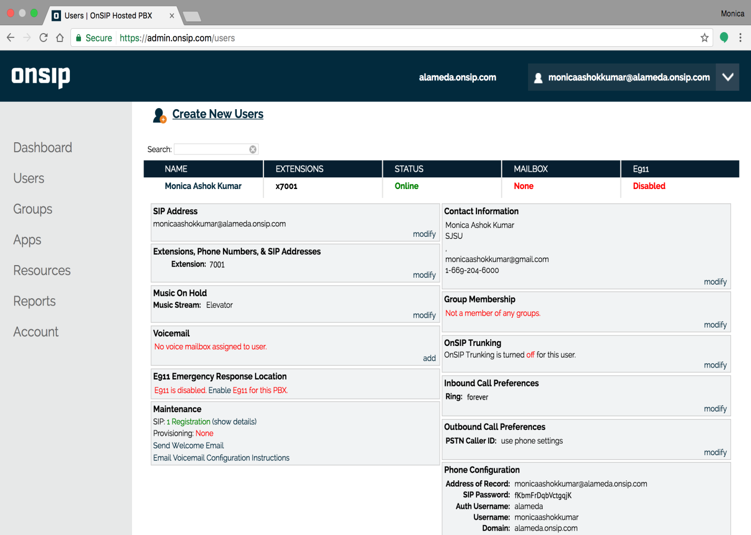

**Fig:** SIP Domain details

**Lab proceedings:**

We have made analysis for video and audio calls separately with the use of Jitsi application.

**Audio Analysis:**

* Jitsi is setup on two computers.
* User from one computer makes an audio call to another user. Below are the screenshots for the same.

Snapshots show call initiation, ringing, connected, disconnected and busy steps

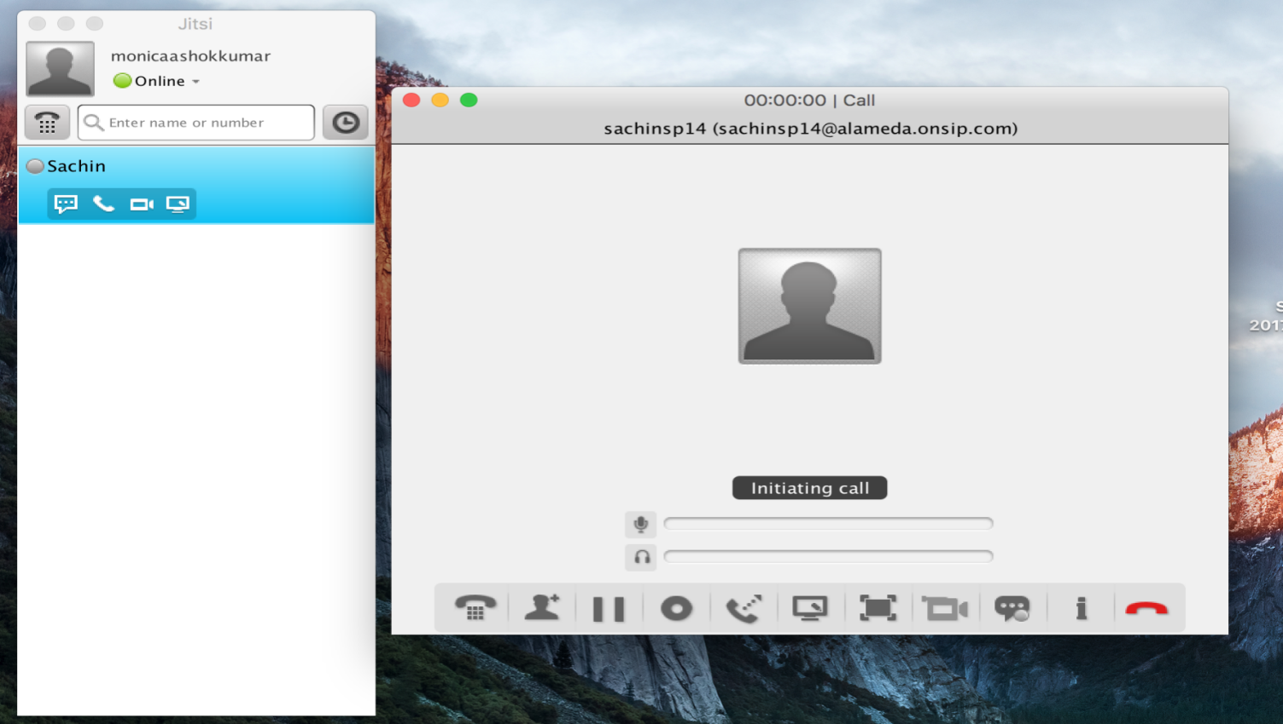

**Fig:** Initiating Call

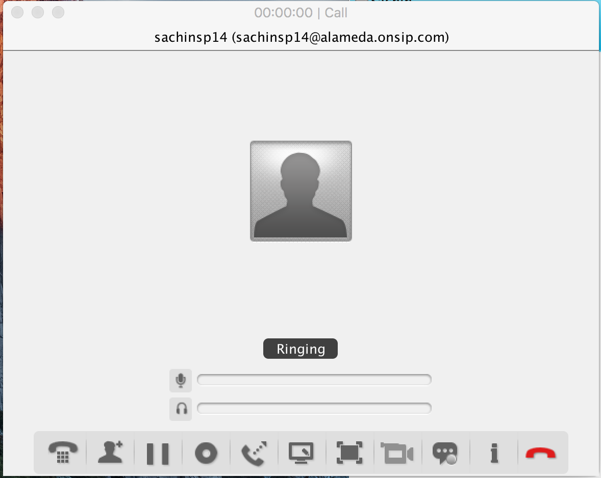

**Fig:** Call Ringing

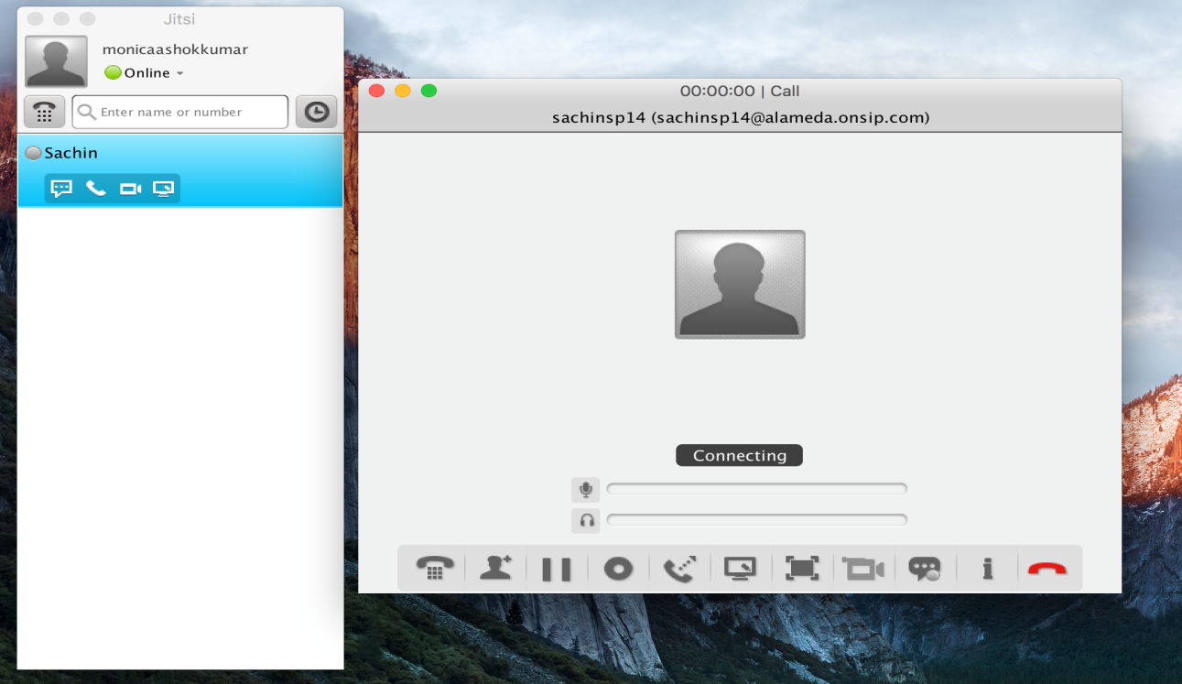

**Fig:** Connecting Call

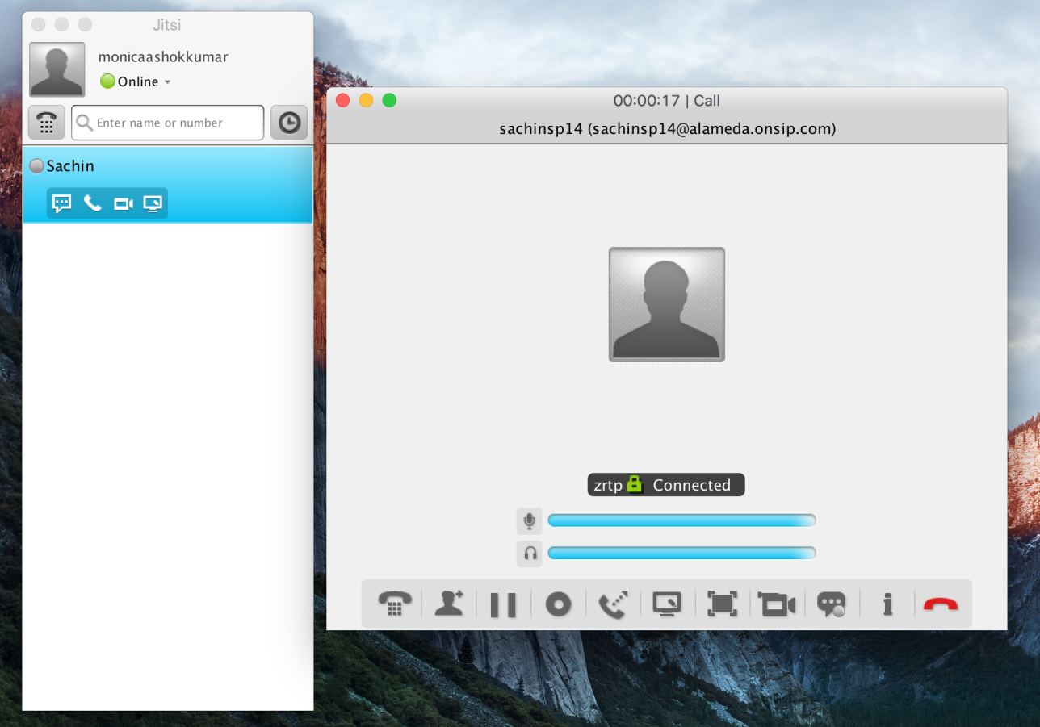

**Fig:** Call Connected

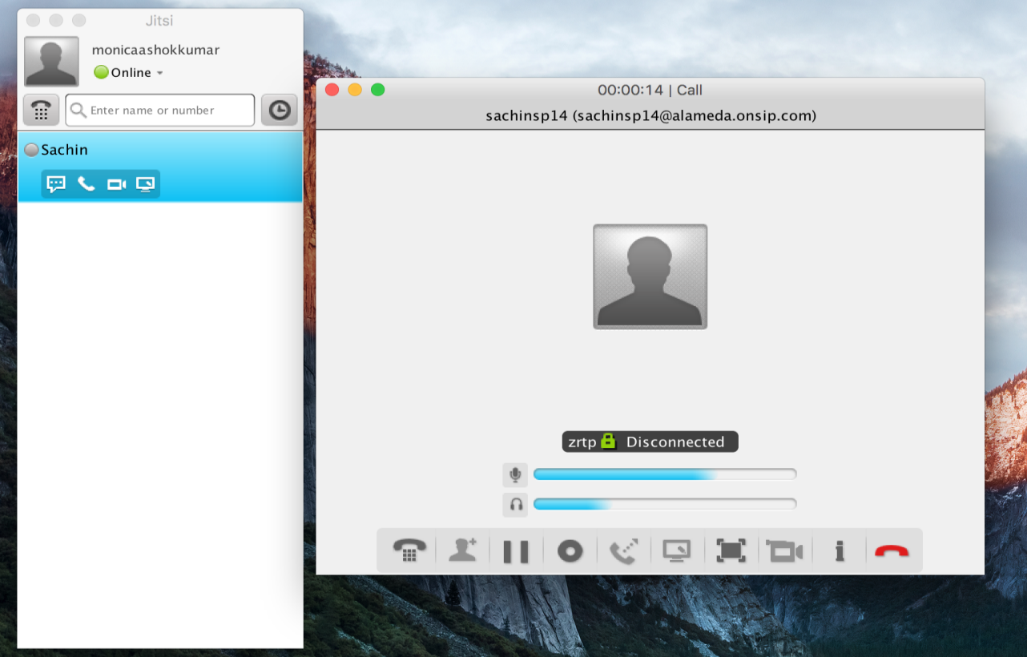

**Fig:** Call Disconnected

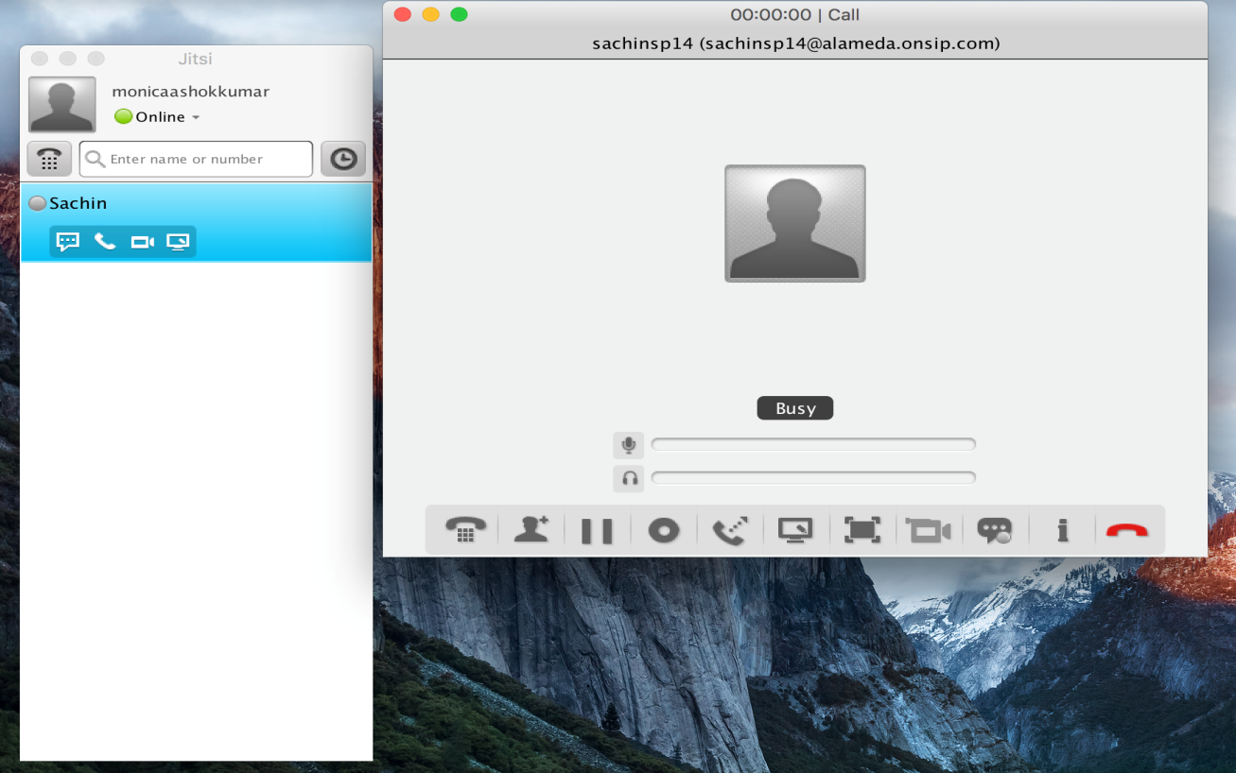

**Fig:** Call Busy

**Video call:**

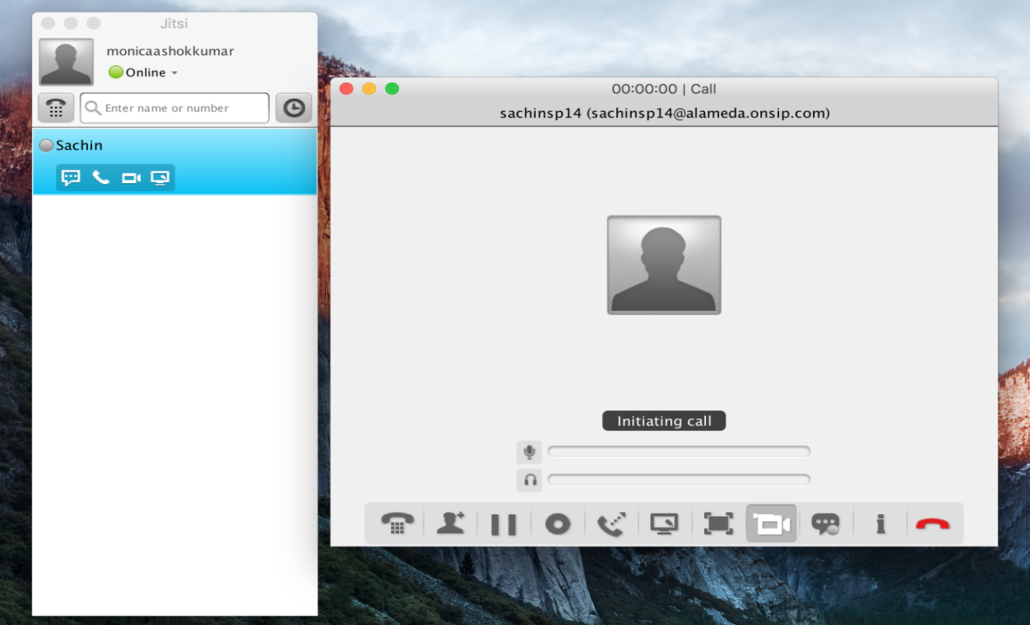

**Fig:** Initiating Call

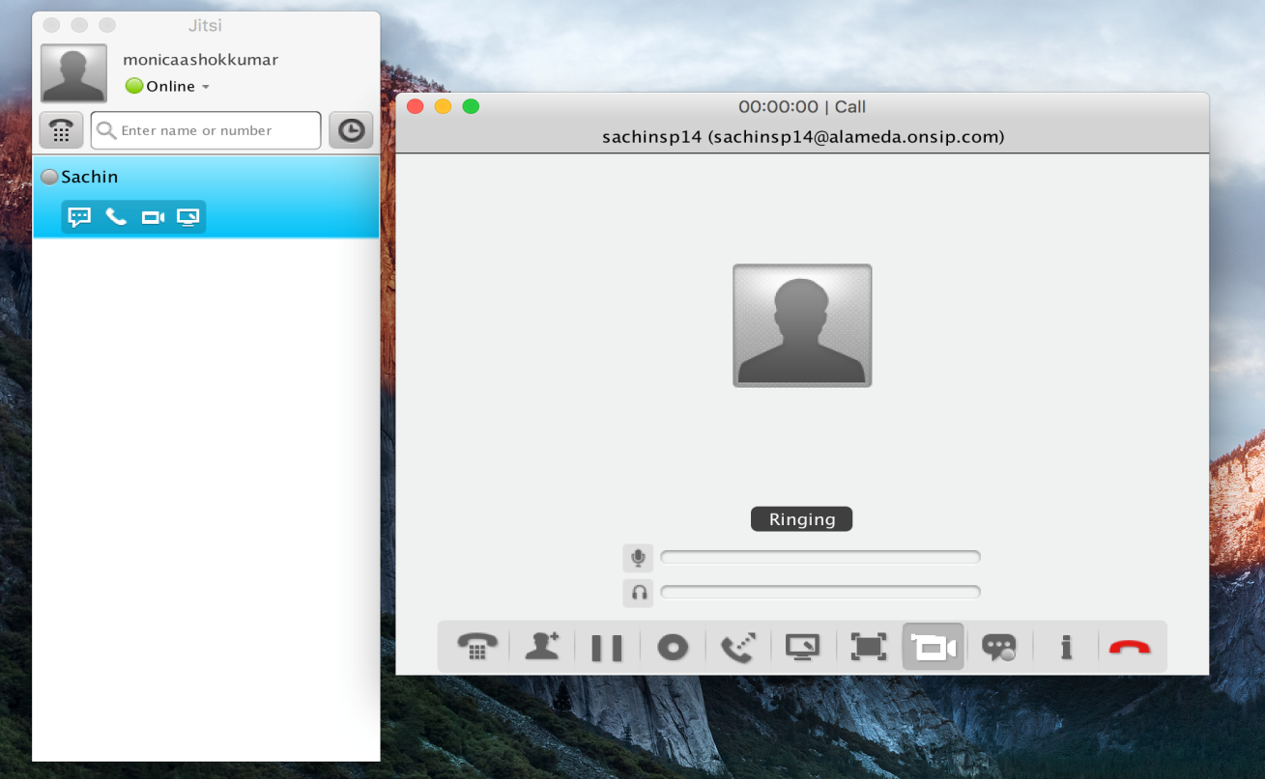

**Fig:** Call Ringing

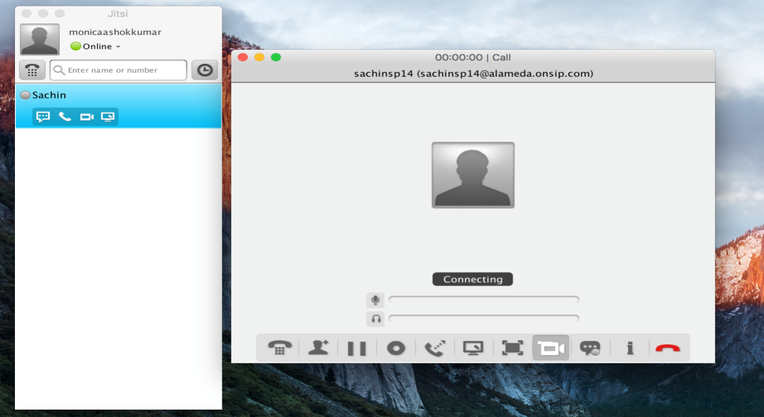

**Fig:** Connecting Call

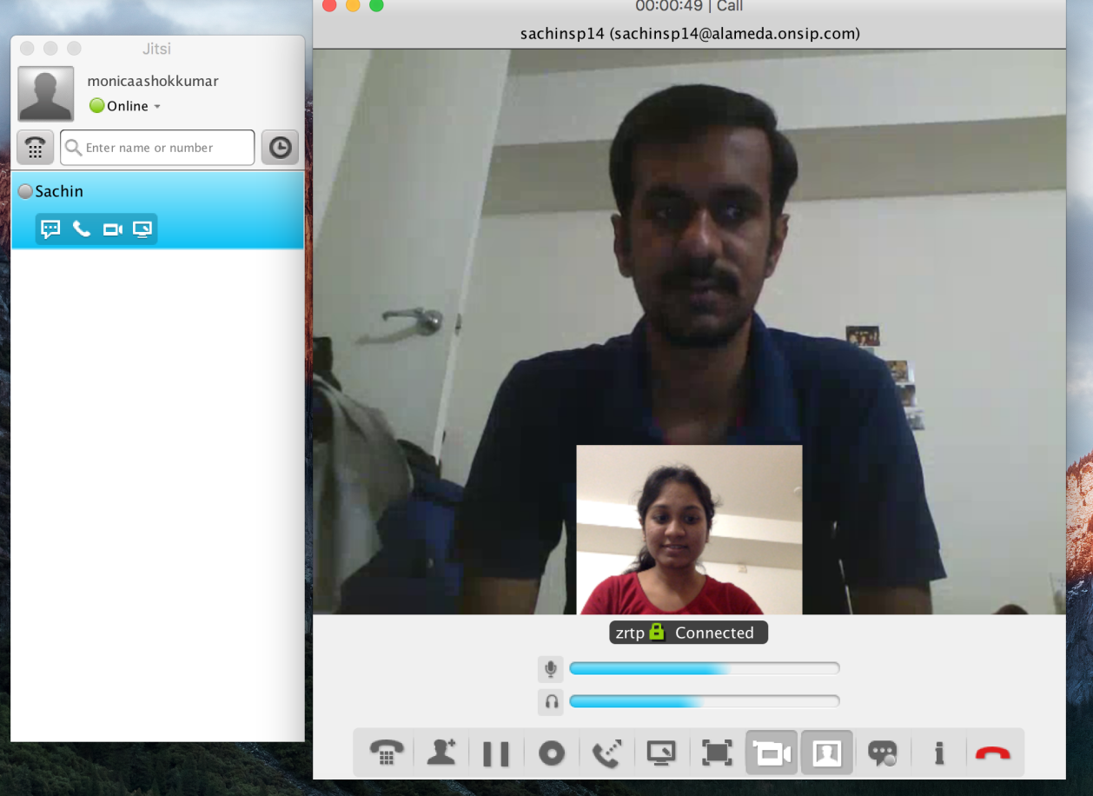

**Fig:** Call Connected

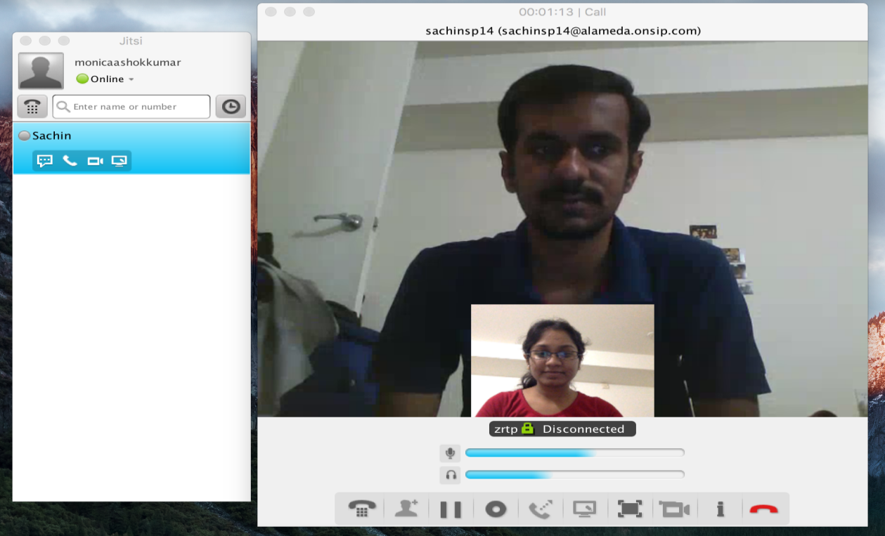

**Fig:** Disconnecting Call

During the time of call wireshark is started and packets are captured for analysis.

Below are the snap shots of wire shark for audio and video call:

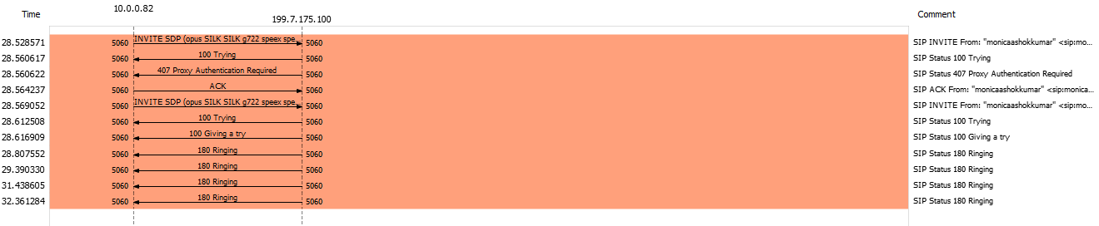

**Fig:** Call Flow Sequence in a Ringing Call

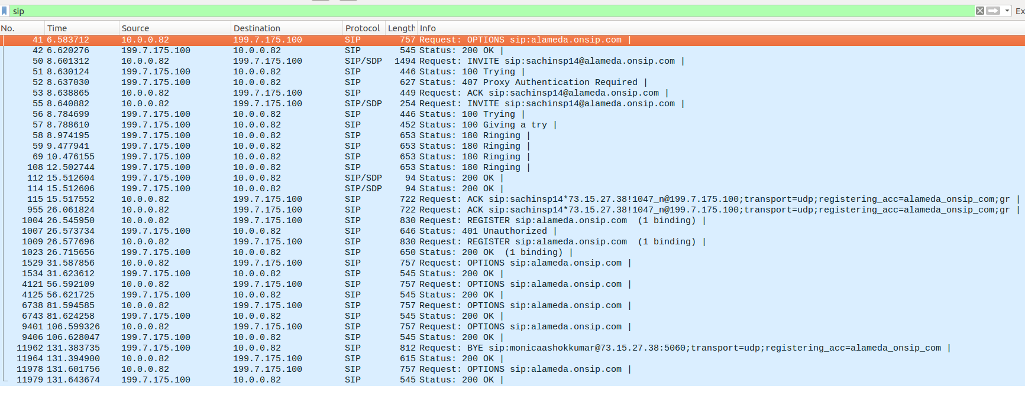

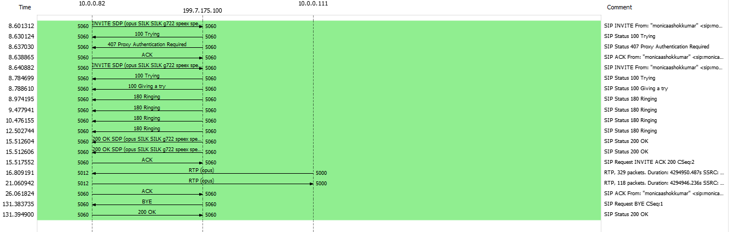

**Fig:** Call Flow Sequence in a Complete Call

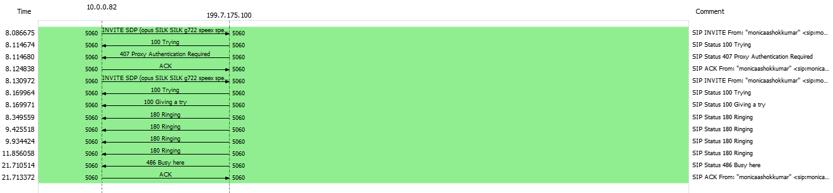

**Fig:** Call Flow Sequence in a Busy Call

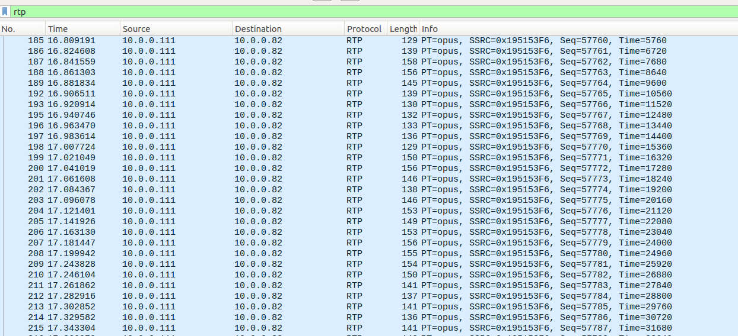

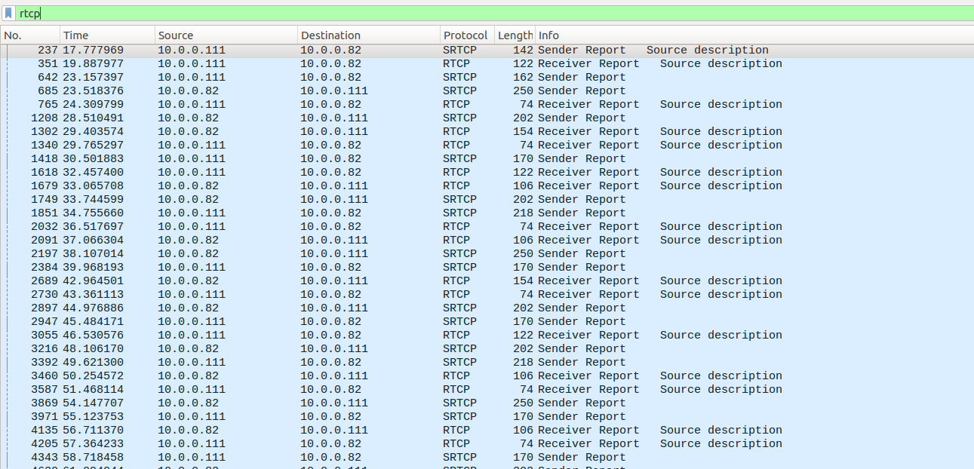

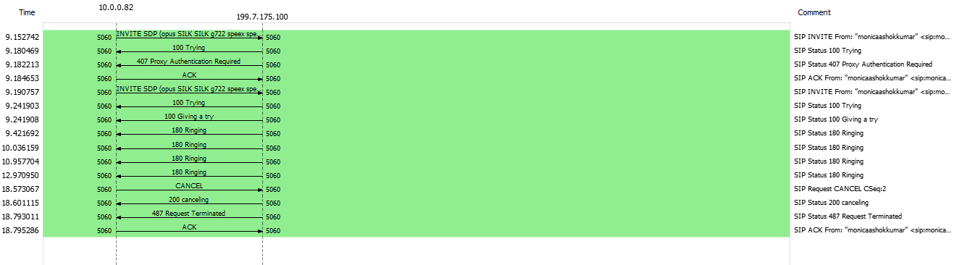

**Fig:** Call Flow Sequence in a Cancel Call

**SIP Attacks:**

**Flooding Attack:**

This attack is mainly used by the attackers to guess the authentic user's password and to cause Denial of Service in SIP registrar. Attacker sends large number of registration requests to the registrar. It can be from single source or multiple sources.

Once the attacker manages to paralyze the registrar it can easily cause DoS. This can be avoided only if SIP server blocks all the messages from unknown origins.

**Parser Attack:**

This attack is also called "message tampering". SIP is a simple text-based protocol. An efficient parser is required which parses messages up to the required point of information. This attack happens by default since the SIP messages are transmitted in normal plain text. Attacker can easily manipulate the SIP address.

**Message Flows Attack:**

SIP protocol uses methods to terminate or end the session, cancel an invitation, update session parameter and redirect a call. Common SIP methods used for these are BYE, CANCEL, REFER and INVITE-UPDATE. Attacker will try to exploit any vulnerability in order to cause DoS. Attacker uses these attacks mainly for improper authentication mechanism. The following are some common message flow attack:

* + The ‘BYE’ Attack
  + The “CANCEL” Attack
  + The “REFER” Attack
  + The “Re-INVITE” Attack
  + The “UPDATE” Attack
  + The “INFO” Attack

**DNS Blocking Attack:**

Main purpose of these attacks are to make SIP agents vulnerable to DoS attacks through invalid DNS lookups. Attacker sends messages with invalid host names, forcing the DNS service to perform unsuccessful and time consuming host look ups. SIP agent keeps on waiting for the reply from DNS subsystem and will not be able to process other pending messages which makes it highly vulnerable to flooding attacks.

**Application**

SIP trunking is native form of Voice over Internet Protocol(VoIP) service offered by carriers. SIP trunking provides direct connection between Internet telephony service provider and organization. It helps in enabling VOIP beyond organization's firewall without need for an IP-PSTN gateway.

SIP enabled video surveillance cameras alerts owners by making calls to them informing the events that occur; for example, to notify the detection of motion in the protected area in out-of -hours.

Many [VoIP](https://en.wikipedia.org/wiki/VoIP" \o "VoIP) phone companies provides customers to use their own SIP devices, such as [softphones](https://en.wikipedia.org/wiki/Softphone" \o "Softphone) or SIP-capable telephone sets.

SIP provides inter-operable means for audio interfaces of different vendors to make connections with one another by using [audio over](https://en.wikipedia.org/wiki/Audio_over_IP" \o "Audio over IP) IP broadcasting.

**Learning from project:**

1. SIP is application layer protocol which is used to create sessions for transmission of media information.
2. RTP protocol is used to send the media packets.
3. RTCP is used for control information of RTP and statistics information.
4. Understood the complete flow of methods and packet contents of SIP.
5. SIP is only associated with signaling, initiation and maintaining information of the call and is not associated with any QOS related to the VOIP call.

**Conclusion**

SIP has been used for services related to Voice over Internet Protocol. SIP helps in creating and terminating the sessions to transfer the media information between the users. It helps in communication between user agents who doesn’t know about each others location. This project helped us to learn and analyze the SIP, RTP/RTCP there components, message flow, attacks in detailed manner.

**References:**

1. <http://users.auth.gr/dgeneiat/papers/journal/Journal-01.pdf>
2. <https://www.slideshare.net/Catharine24/a-sip-attack-detection-prevention-architecture?qid=18807c85-4015-4497-92b0-dbdaeb82a84b&v=&b=&from_search=1>
3. <https://en.wikipedia.org/wiki/Session_Initiation_Protocol>
4. <https://www.tutorialspoint.com/session_initiation_protocol/session_initiation_protocol_messaging.htm>
5. <http://www.siptutorial.net/SIP/index.html>
6. <http://www.siptutorial.net/RTP/packetrtcp.html>